**GOLDEN ELITE EXAMINTIONS 2020**

312/2

GEOGRAPHY

PAPER 2

**MARKING SCHEME**

**SECTION A**

**Question 1.**

(a) An *environment* is the physical conditions surrounding an organism and which influence the behavior of that organism. ***(1x2 = 2 marks)***

(b) ***Effects of the following environmental hazards.***

(i) *Earthquakes*

* Leads to loss of lives
* Destroys property. (***1 x 2 = 2mks)***

(ii) *Nuclear wastes*

* Releases harmful radiations
* Causes loss of human and animal lives (***1 x 2 = 2mks***)

**Question 2.**

(a) ***Two species of hardwood forests grown in Kenya.***

* Meru oak , Elgon teak, Red Ceda, Mvule, Muringa , Mahogany, Ebony, Cape chestnut

***(2 x 1 = 2mks)***

(b) ***Three factors that favor the development of softwood forest in Kenya.***

* Cool climate enable trees to grow / flourish
* Highlands receive high amount of rainfall
* Rugged highlands discourage settlement and agriculture leaving forestry as the alternative
* High demand for softwood products encourage tree planting
* Deep soils favour forest growth
* Soft woods grow quite fast due to warm temperatures ***(Any 3, 3 x 1 = 3mks)***

**Question 3.**

(a) *Mining* refers to all attempts to attract valuable minerals either solid, liquid or gas from the earth’s crust.

(b) ***Two factors that have influenced exploitation of minerals.***

* Minerals that are of high demand and economic value may be mined at a very high cost because they can be sold at high prices e.g. gold, petroleum e.t.c.
* Value of the mineral: Valuable minerals like gold are oftenly mined at high costs without loss of profits while less valuable minerals are not readily mined.
* The size of any mineral reserve must be big enough to justify the purchase and the use of expensive equipments needed for exploitation. Small deposits are hardly mined.
* Quality of mineral ore: High quality ores are economical to mine while low quality ores are rarely mined.
* Transport costs:Its more economical to exploit minerals near industrial centres
* Labour
* Method of extraction (**Any 4 points 4 x 1 = 4mks)**

**Question 4**

(a) ***Two limitations of using photographs.***

* Vertical aerial photographs are difficult to interpret without special instruments e.g. stereoscopes
* Photographs are expensive to produce
* Cameras need well focusing to avoid blurred images
* Objects that are far away from the camera may not be clear thus leading to wrong interpretation.

(***Any 2 points 2 x 1 = 2mks***)

(b) ***Two types of ground photographs.***

* Ground close-up photographs
* Ground general view photographs
* Ground oblique photographs (***Any two points 2 x 1 = 2mks)***

**Question 5.**

(a) ***Two exotic dairy cattle breeds reared in Kenya.***

* Guernsey , Friesian/Holstein, Jersey, Alderney , Aryshire, Brown Swiss (***Any 2 points 2 x 1 = 2mks)***

(b) ***Two physical factors which favour dairy farming in Denmark.***

* Gentle sloping landscape ideal for grazing
* Warm climate / sunny summer/ moderate temperatures 10-170C that allows outdoor grazing
* Cool climates ideal for pasture growth
* Moderate rainfall (500-1000mm) that supports growth of pasture / fodder crops
* Fertile boulder clay soils***(Any 2 points 2 x 1 = 2mks)***

**SECTION B.**

**Question 6**

1. Grand total of vehicles moving past the gate on Monday.

* 1,740 vehicles ***(2marks)***

1. ***Simple pie chart showing the type of vehicles moving past the gate on Monday (radius = 3cm)***

* Isuzu – 260 x 360 = 53.80

1740

* Leyland – 340 x 360 =70.30

1740

* Toyota – 460 x 360 =95.20

1740

* Nissan – 400 x 360 =82.80

1740

* Others – 280 x 360 =57.90

1740

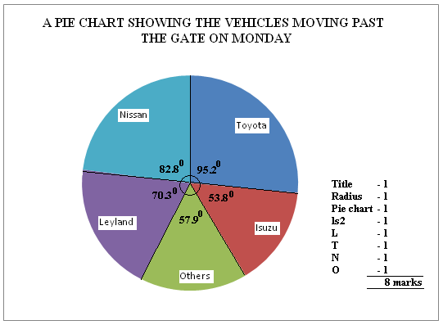

1. ***Merits of using a simple pie chart to represent the above data.***

* It gives clear visual impression of individual components
* It can be used to represent a wide range of statistical data
* Easy to read and interpret
* Clearly shows individual amounts and clear comparison of individual quantities
* Its simple / easy to construct after angles have been obtained
* It gives a good visual impression. ***1 x 5 = 5mks***

1. ***Other five ways used to present statistical date.***

* Graphs
* Proportional circles
* Pie charts
* Statistical tables / charts
* Age-sex pyramids
* Dot maps ***(1 x 5 = 5mks)***

1. ***Five methods of collecting statistical data***.

* Questionnaire
* Interviews
* Observation
* Sampling
* Taking measurements
* Experimentation
* Content analysis (secondary sources)
* Counting ***(Any 5 = 5 x 1 = 5mks)***

**Question 7**

(a) ***Types of natural forests in the world.***

* Tropical hardwood forests
* Temperate hardwood forests
* Coniferous forests ***(3 x 1 = 3mks)***

(b) ***Significance of forests and forest products in Kenya.***

* Preservation and conservation of environment
* Acts as water catchment areas
* Regulation of climate / create a micro climate
* Provide habitat for wildlife
* It’s a source of income
* Acts as a raw material for industries e.g. paper industry
* It’s a source of employment e.g. forest guards, officers
* It promotes tourism
* It provides charcoal
* Provides fodder for animals
* Forest provide nuts, fruits and dyes, ropes nets, honey.
* It’s a hiding ground for military.
* Its an educational and research centre
* Provides wood and poles for building and construction
* It’s a source of tree leaves which are fed to silkworm (***Any 5 explained 5 x 2 = 10mks)***

(c) ***How Kenya government has done to conserve and manage forest.***

* Carrying out public campaigns on the value of forests through mass media
* Carrying out research on suitability of soils and effects of pests and diseases
* It has established training institutions dealing with forestry e.g. KEFRI, Londiani forest training college.
* It has encouraged rotational felling of trees
* Infrastructural facilities like roads & mills have been provided by government.
* The government has introduced alternative sources of energy (fuel) e.g. solar energy, biogas to reduce overdependence on wood fuel
* It has enacted laws to govern the management of forests.
* It has employed forest guards and officials to curb destruction of forests
* N.G.O’s like Green Belt Movement and UNEP provide seedlings for forests.
* It has created forest reserves
* It has encouraged agro-forestry
* Extensive afforestation programme is underway***(Any 5 points 5 x 1 = 5mks)***

1. (i) ***5 factors influencing the distribution of natural forests.***

* Climate
* Altitude
* Soils
* Human activities
* Aspects & Slope.***(5 x 1 = 5mks)***

(ii) The ***management of forests*** refers to the effective planning and control of forests and forests resources.

***(1 x 2 = 2mks)***

**Question 8**

(a) ***A mineral*** is a naturally occurring, crystalline, inorganic substance with a definite chemical composition and physical properties.***(2 x 1 = 2mks)***

(b) ***Forms in which minerals occur.***

* Veins and lodes; Minerals deposited in crystalline form in crack / crevice
* Beds and seams; Coal and other minerals may occur in bed / layers as a result of deposition, accumulation and concentration in horizontal layers of earth crust.
* Weathering products; Like Bauxite is formed by deep weathering of a variety of rocks due to alternating wet and dry seasons
* Alluvial / placer deposits;some minerals like gold, tin and platinum occur as alluvial deposits within sand, clay and gravels in the river course. ***(4 x 2 = 8mks)***

(c) ***Significance of minerals in Kenya.***

* Rocks create beautiful sceneries which attract tourists hence earn Kenya foreign exchange.
* Rocks act as water reservoirs and store underground water
* Rocks provide parent material for formation of rich soils for agriculture
* Rocks are used in building and construction industry
* Rocks and mineral are sources of income
* Rocks provide main record of past environment
* Rocks influence landscape features
* Exploitation of rocks and minerals has led to dereliction (***Any 5 points 5 x 1 = 5mks)***

(d) (i) ***Preparations made before the study.***

* Discussing / studying the topic of study
* Seek permission from authorities
* Collect required materials
* Conduct a reconnaissance
* Prepare questionnaires
* Divide into groups
* Prepare a working schedule***(Any 3 pts (3 x 1 = 3mks)***

1. ***Problems encountered during the study.***

* Fatigue
* Uncooperative respondents
* Financial constraints
* Language barrier
* Unfavourable weather condition like floods
* Accidents in the field
* Inaccessibility
* Thick vegetation that’s difficulty to penetrate ***(Any 2 points = 2mks)***

1. ***Importance of studying geography through field work.***

* It gives first hand information
* It breaks classroom monotony
* Teaches skills e.g. observation skills
* Enhances learning in the real life situation
* Encourages critical thinking
* Enables one to understand his / her environment***(Any 5 points 5 x 1 = 5mks)***

**Question 9**

(a) (i) ***Social factors which influences agriculture .***

* Technology , religion, gender roles, foreign influence ***(Any 3 = 3mks)***

(ii) Types of maize grown in Kenya.

* Dent corn
* Sweet corn ***(2 x 1 = 2mks)***

(b) (i) ***Areas in Kenya where maize is commercially grown.***

* Eldoret
* Kitale
* Nakuru ***(any 2 x 1 = 2mks)***

(ii) ***Stages involved in the industrial processing of maize.***

* Maize grains are weighed and then put on trays
* Any undesirable grains and broken cobs are removed
* Maize is then sieved to remove any impurities like soil / rock particles
* The maize is then passed through a milling machine which grinds it into flour
* The flour is then packed into small packets and sacks according to the desired weight
* Packets are sized 1 kg, 2 kg, and 10kg while sacks weigh more than 50kg

***(Any 4 pts 4 x 1 = 4mks)***

(c) ***Problems facing maize farmers in Kenya.***

* Pests e.g. stalkborers, army worms, weevils
* Diseases e.g. white leaf blight
* Adverse weather conditions like drought , floods
* Parasitic plants and weeds
* Price fluctuation
* Poor quality seeds sold by unscrupulous traders
* Inadequate storage facilities
* Expensive certified seeds
* Expensive farm inputs ***(Any 4 pts 4 x 1 = 4mks)***

1. (i) ***Ways through which the Kenya government assists small scale maize farmers.***

* Arrange buying of maize through the cereal boards
* Conduct research to establish areas best suited for maize growing and research on diseases
* Organize demonstrations firms and field days to update farmers on current methods
* Employs extension workers who visit farmers and advise them on matters related to maize growing
* Encourage farmers to set up co-operatives to enable them pool resources together
* Improves feeder roads to ensure smooth transport of maize produce

***(Any 3 x 2 = 6mks)***

(ii) ***Uses of maize.***

* Staple food
* Stalk, leaves and other remains from maize cobs are used to feed domestic animals
* Stalks and cobs are used to provide domestic fuel
* Stalks and cobs are used as organic manure
* Grains are used in the making of corn oil.***(Any 4 x 1 = 4mks)***

**Question 10**

(a) (i) ***Natural vegetation*** is the plant cover that exist naturally in an area without the interference of any external modifying influence e.g. man.***(1mark)***

(ii) ***Topographical factors influencing distribution of vegetation***.

* Relief
* Aspect
* Drainage***(Any 2 well state points 2 x 1 = 2mks)***

(b) (i)**Objectives for the study.**

* To find out the type of vegetation around the school
* To determine the use of the vegetation around the school.

***(Any other relevant point 2 x 1 =2mks)***

(ii)***How would you record the findings in your study?***

* Note taking.
* Sketching.
* Tabulating.
* Phototaking. (***Any other relevant point 4 x 1 = 4 marks)***

(c) ***Well labeled diagram showing vegetation zonation on a mountain slope.***

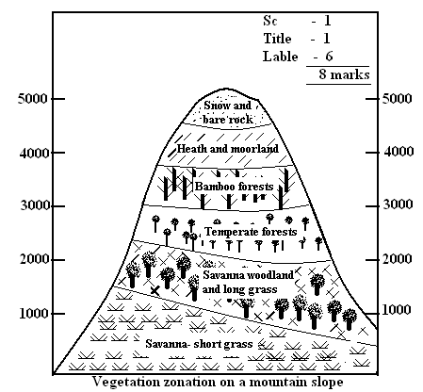

(d) (i) ***Adaptation features of tropical desert vegetation.***

* They have succulent stems
* Leaves are reduced to thorns / spikes
* They have long tap roots
* Some plants complete their life cycle within a short period
* They shed their leaves during dry season

***(Any other relevant point 5 x 1 = 5mks)***

(ii) ***Two economic importance of desert vegetation***.

* The vegetation adds beauty to the landscape
* The vegetation prevents soil erosion by binding the soil together
* The vegetation acts as a habitat for wildlife
* Some plants have medicinal value
* Some desert vegetation are used in building and construction
* Some plants are consumed as food by people
* Fibrous vegetation like sisal are used to make ropes
* The vegetation is a source of fuel either as firewood or charcoal

***(Any 2 points 2 x 1 = 2mks)***